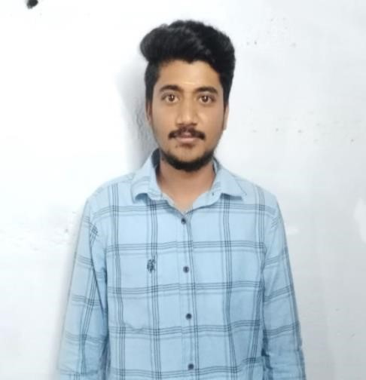

.



Gowthaman B

COMPUTER

APPLICATIONS

(

BCA

)

**Contact:**

Ph

.no

6385802695

Mail Id

:

gowthama848@gmail.com

Near

Union office,

Modakurichi-638104

,

-

**TECHNICAL**

**SKILLS:**

C and C++

Java

**CE**

**RTIFICATES**

**:**

Linked in

FOOTBALL

**PERSONAL**

**TRAITS:**

•

Positive minded

•

Critical thinking &

problem

solving

•

A good initiator.

EDUCATION

Bachelors of

COMPUTER

A

PPLICATIONS

BCA

(

)

Nandha Art

s And Science

College

2023

-

26

with the

percentage of

%

62

Hsc 2nd y

Year in

,

Government

Boys Higher

Secondary School

in 2022

-

23

In the group of

COMPUTER

APPLICATIONS

with percentage

Of 68.3 %

SSLC in,

Government

Boys

Higher Secondary School Modakuruchi

in 20

20

-

2

1

With the percentage of

%

INTERNSHIP

web development

course

DECLARATION

:

I

hereby

furnishing

the

above

details

are

true to the best of

my

knowledge





